Pick three concepts covered in Lecture 9 - Interaction (e.g., Brushing & Linking) and relate them to the taxonomy presented in Heer & Shneiderman Table

How do the interaction concepts fit to their taxonomy?

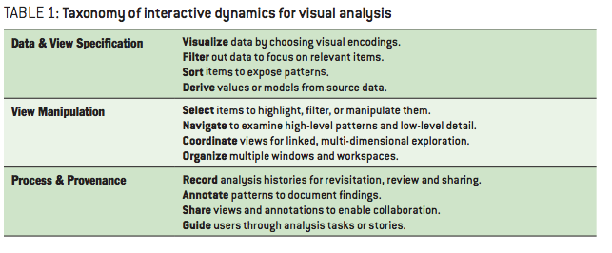

In the lecture several interaction concepts are mentioned. I will relate three of them to the taxonomy presented in the Heer & Shneiderman table.

The first is focus + context. This is a fairly broad concept, but it comes down to focusing on a certain element of the visualization. An example is the fish eye view. Without changing the level of distortion, the focus can be put on a certain point. Another method to do this is brushing. This refers to highlighting a certain part of the data in a separate window. Another way to focus attention on a certain part is by making use of a hyperbolic tree. I believe focus + context belongs to the group “View Manipulation.” This is so because it guides the attention of the user to a specific point. In that sense, the users view is manipulated.

The second interaction concept I want to discuss is animation. Animation can be used for visualization, but also it is often used to guide users through a visualization. To show them a process over a span of time, like the growth of Walmart over the United States. It is therefore a part of the Process & Provenance group.

The final interaction technique I want to discuss is filtering. What this means is that the user is given several filters, which allow him or her to narrow down the amount of data in the visualization. This is especially useful if the user is confronted with large sums of data. It therefore makes sense that this is part of the Data & View specification.